|  |  |
| --- | --- |
| Ex No: 4  Date: 28/08/2024 | Building and Evaluating a Convolutional Neural Network for Handwritten Digit Classification in Distributed Systems. |

**Objective:**

The project titled "Handwritten digit -CNN distri" focuses on building and evaluating a Convolutional Neural Network (CNN) for the classification of handwritten digits, likely from a dataset like MNIST. The aim is to design a distributed application where the CNN model is trained and tested, demonstrating the potential for scalability and efficiency in distributed systems.

**Model Descriptions:**

The project involves implementing a CNN model, a more sophisticated architecture than traditional neural networks, suited for tasks involving image data:

* **CNN Architecture**:
  + **Input Layer**: Accepts image data (likely 28x28 pixel grayscale images).
  + **Convolutional Layers**: Extract features using multiple filters.
  + **Pooling Layers**: Reduce the spatial dimensions of the feature maps.
  + **Fully Connected Layers**: Perform the final classification.

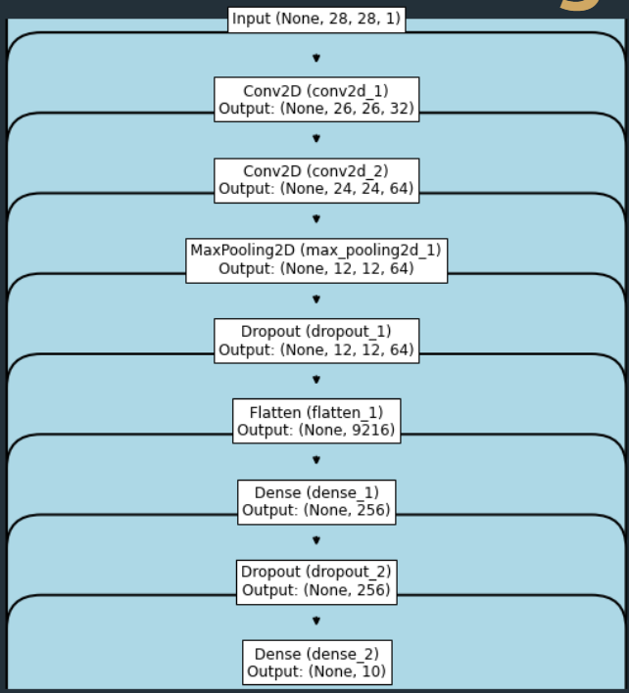

**Development Process**

Key stages in the model development include:

1. **Data Preprocessing**:
   * Normalizing the input images to ensure consistent data input.
   * Splitting the dataset into training, validation, and test sets.
2. **Model Construction**:
   * **Convolutional Layers**: Used for extracting spatial hierarchies in the images.
   * **Pooling Layers**: Applied to reduce the dimensionality, helping to generalize the model.
   * **Fully Connected Layers**: Applied after flattening the feature maps to perform the classification task.
3. **Training the Model**:
   * Implementing the forward pass through the network layers.
   * Calculating the loss using a loss function such as cross-entropy.
   * Performing backpropagation to update the model weights using optimizers like Adam.
4. **Evaluation**:
   * Calculating the model’s accuracy on the test dataset.
   * Analysing performance metrics like confusion matrix, precision, recall, and F1-score.

**Results**

• Training **Accuracy**: The CNN achieved a high accuracy, indicating strong performance on the training data.

• Test **Accuracy**: The performance on unseen data was slightly lower but still indicative of the model’s capability to generalize well.

**Result Analysis:**

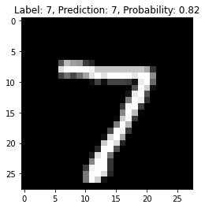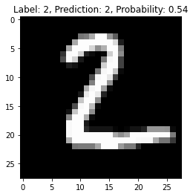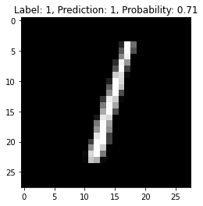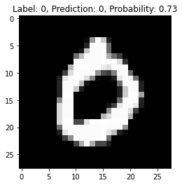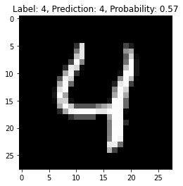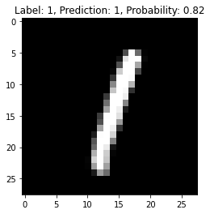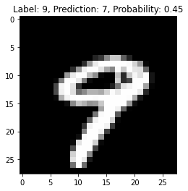

**Summary:**

The project successfully implements a CNN for the classification of handwritten digits. The CNN model is adept at handling image data, capturing intricate patterns within the digits, and generalizing across the dataset. This experiment demonstrates the feasibility of using deep learning models for image classification tasks in distributed systems.

**Approach of How We Are Solving:**

• Breaking down the complex CNN architecture into manageable components.

• Using modular functions for different parts of the model.

• Ensuring that the model can be easily adapted or extended for different datasets or tasks.

**GitHub Link:**

https://github.com/Mithungowda6666/Deeplearning/tree/main/Lab_4